1. Name of the Student (s) : Ms.S.Sanjavi IV year
: Ms.M.Subiksha IV year
: Ms.R.Sugha priya IV year
: Ms.E.Swetha IV year

One valid e-mail id : ramyasigamani77@gmail.com

Name of the Guide : Mrs.T.G.Ramya Priyatharsini

Department / Designation :Information Technology/Assistant Professor
Institutional Address : Dhanalakshmi Srinivasan Engineering
College (Autonomous),Perambalur-621212

Phone No.& Mobile No. : 9150913873

Title of Project : Deep Learning-Based Framework for
Detecting Facial Morphing and
Synthetic Media Content

2. Sector in which your : Engineering and Technology.
Project proposal
is to be Considered

3. Project Details : Annexure I

4. Has a similar project been carried : NIL
Out in your college/elsewhere?
If so,furnish details of the previous
Project and highlight the improvements
Suggested in the present one

ANNEXURE I
Title of the Project:

Deep Learning-Based Framework for Detecting Facial Morphing and Synthetic Media Content
Objectives:
To develop a web or mobile application that allows users to search for videos, images, and news contentand verify whether that content is original or fake, using AI-based analysis, metadata checking, and reliable fact-checking sources.
Scope:
- Input: Upload or link to a video, image, or news article
- Output: Verdict – Original, Edited, Fake, or Unverified
- Include sources or proof (e.g., reverse image search, fact-check articles)
- Accessible via website or mobile app
Core Technologies:
- Frontend: React.js or Vue.js (Web) / React Native or Flutter (Mobile)
- Backend: Node.js / Django / Flask
- Database: MongoDB or PostgreSQL
- ML/AI Tools
Documentation:
- Developer documentation (API usage, model training)
- User documentation (How to verify content)
- Privacy policy for handling user-uploaded
INTRODUCTION
In the digital age, the manipulation of images has become increasingly sophisticated and accessible, posing significant challenges in verifying the authenticity of visual content. With the rise of powerful editing tools and deep learning-based techniques such as deep fakes and image morphing, distinguishing between original, morphed, and fake images has become a critical concern across multiple domains, including media, forensics, security, and social media.
Detecting such manipulations requires advanced techniques that go beyond the human eye. Computational methods, including machine learning, deep learning, and digital forensics, are employed to analyze image inconsistencies, artifacts, and metadata to determine whether an image is original or has been altered
This study/project aims to explore and implement techniques to detect morphed and fake images, differentiate them from original ones, and understand the underlying methods used for both image creation and detection. The goal is to contribute to the growing field of image forensics and help build tools that support digital integrity and trust.
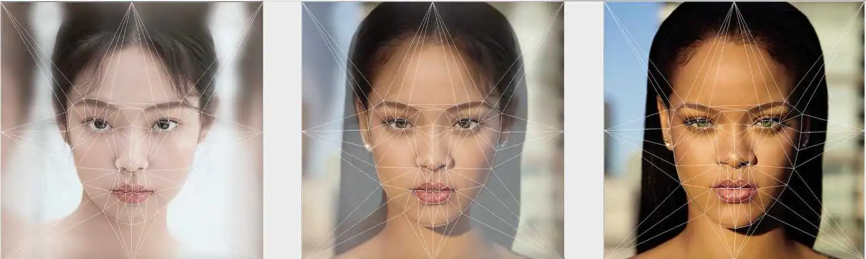
Figure 1: Manipulated Images
The image showcases a comparative analysis of facial symmetry using the Golden Ratio mask, a standard tool used in studies of human facial aesthetics and proportions. Each portrait is overlaid with geometric lines representing the ideal facial structure as defined by the Golden Ratio (Phi Mask). This illustration highlights how different faces align with or deviate from these ideal proportions, offering insights into the mathematical basis of perceived beauty and symmetry. Such analysis is pivotal in fields like cosmetic science, artificial intelligence-based facial recognition, aesthetic surgery, and psychological studies of human perception.
METHODOLOGY
Feature extraction
- Error level analysis,frequency domain analysis
- conventional neural networks (CNN)
Model training and user interface
- Machine learning and deep learning models
- Webmobile interface (API)
Evaluation and validation
- Accuracy, precision ,recall and F1 score
- distinguish between orignal and fake media
Smart Detection of Facial Forgery and Deepfake Content Using Deep
Learning
Data collection and preprocessing
- Data set - original and manipulated image
- Relevant features - facial landmarks , meta data

Project Impact:
The development of a Deep Learning-Based Framework for Detecting Facial Morphing and Synthetic Media Content holds significant implications for digital security, privacy, and media authenticity. As facial morphing and synthetic media (such as deepfakes) become more sophisticated and accessible, they pose serious threats to biometric authentication systems, personal identity, and the trustworthiness of digital information.
This project contributes to the mitigation of these threats by providing a robust, automated detection system that leverages advanced deep learning techniques. The framework enhances the capability of law enforcement, media platforms, and cybersecurity systems to accurately identify manipulated content, thereby reducing fraud, misinformation, and identity theft.
Furthermore, the project promotes public trust in digital media by enabling verification tools for content authenticity. It also sets a foundation for future research and standardization in the field of digital forensics, supporting broader initiatives in ethical AI and responsible media use.
Problem Identification:
- Facial morphing and synthetic media...pose serious threats to biometric authentication systems, personal identity, and the trustworthiness of digital information.
- This highlights the importance and urgency of the problem being addressed.
Contribution of the Project:
- Provides a robust, automated detection system that leverages advanced deep learning techniques.
- Shows how your work contributes to solving the identified problem.
Beneficiaries:
- Law enforcement, media platforms, and cyber security systems...
- Identifies stakeholders and groups that will directly benefit from your project.

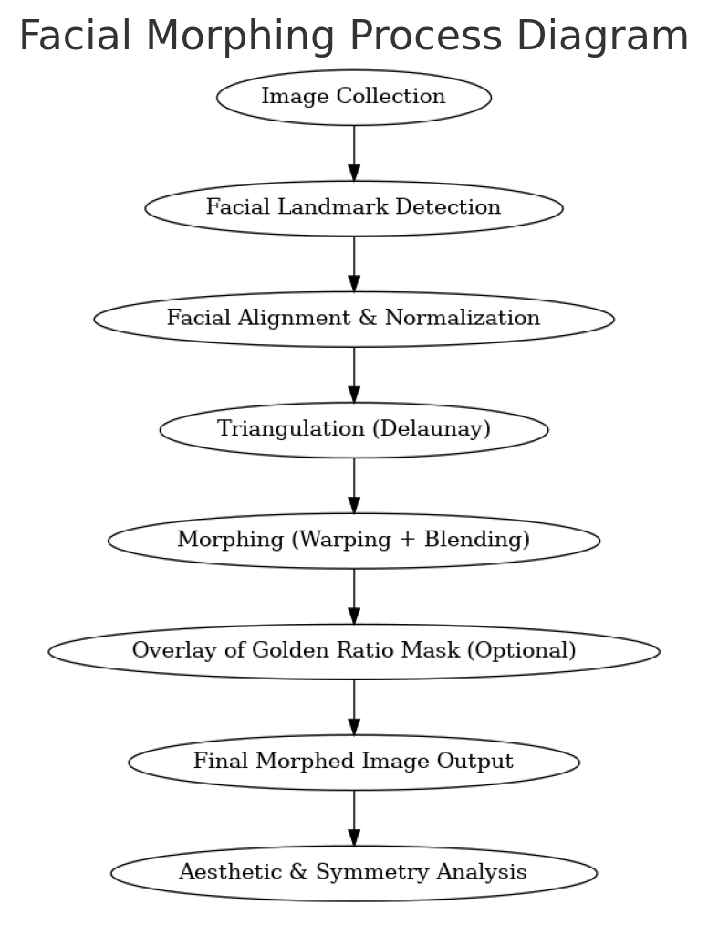
Figure 2: Flowchart

Facial morphing is a computational technique used to blend or transform one face into another by aligning facial features and interpolating pixel values. The process begins with collecting high-quality, front-facing images followed by detecting facial landmarks using machine learning algorithms. These landmarks help in aligning and normalizing the facial structures across different images.
The aligned facial features are then divided into triangular regions using Delaunay triangulation, which ensures smooth warping. Morphing is achieved by warping these triangles from one image to another and blending them seamlessly. Optionally, a Golden Ratio mask can be overlaid on the morphed output to analyze facial symmetry and aesthetics.
The final morphed image is then analyzed to study how closely it aligns with ideal beauty proportions or symmetry standards. This method has applications in cosmetic research, facial recognition, animation, and the study of aesthetic perception in humans.
Components and Outcome of the Project
S.No | Project Component | Outcome
1 | Image Collection | High-quality, front-facing facial images gathered for analysis.
2 | Facial Landmark Detection | Identified key facial points (eyes, nose, lips, jawline) using ML tools.
3 | Image Alignment & Normalization | Standardized image scale and orientation for accurate feature matching.
4 | Delaunay Triangulation | Divided facial area into triangles for smooth morphing.
5 | Morphing (Warping & Blending) | Seamless transformation between faces using pixel interpolation.
6 | Golden Ratio Mask Overlay (Optional) | Overlaid ideal proportions for aesthetic comparison.
7 | Symmetry & Aesthetic Analysis | Evaluated visual harmony and alignment with golden ratio standards.

Table 1: Components and Outcome of the Project

Project Plan:
Table 2: Work Plan and Duration
Work plan | Duration
Finalize project idea & objectives | 10 days
Collect facial image datasets | 15 days
Detect facial landmarks | 15 days
 | 15 days
  Align and pre-process images
Add Golden Ratio mask | 20 days
Test with different face pairs | 15 days

Budget Proposal:
Table 3: Budget
S. No | Particulars | Amount(Rs)
1 | High-Speed SSD (128GB or more) | 2,000
2 | External HDD/USB (Dataset storage) | 2,000
3 | Cloud GPU Credits (Google Colab Pro, AWS,) | 2,000
4 |  | 1,200
  Web Camera / DSLR Integration
5 | Arduino / Display with Buzzer | 1,200
6 | Printing,Binding, Certificates, Reports | 800
7 |  | 800
  HDMI Cable + Connectors
TOTAL ESTIMATION |  | 10,000

References:

1. .Ferrara, M., Franco, A., & Maltoni, D. — “The magic passport” (2014) early,influential demonstration that face morphing can fool automatic/border-control systems (introduces the morphing-attack threat).

2. Rössler, A., Cozzolino, D., Verdoliva, L., Riess, C., Thies, J., & Nießner, M. FaceForensics++: Learning to Detect Manipulated Facial Images (ICCV / arXiv 2019) large, widely used benchmark dataset + baseline methods for multiple face-manipulation types.

3.Afchar, D., Nozick, V., Yamagishi, J., & Echizen, I. — MesoNet: a Compact Facial Video Forgery Detection Network (2018) — lightweight CNN architectures (Meso-4 / MesoInception) tailored for face forgery detection.

4.Li, Y., & Lyu, S. — Exposing DeepFake Videos By Detecting Face Warping Artifacts (CVPRW / arXiv 2019) — demonstrates generalizable artifacts (face-warping / upsampling) and a detection approach that doesn’t require training on every generator.

5.Ngan, M., Grother, P., Hanaoka, K., & Kuo, J. — Face Recognition Vendor Test (FRVT) Part 4: MORPH — Performance of Automated Face Morph Detection (NIST IR 8292, 2020) — authoritative evaluation / benchmark and guidance for morph-detection systems.

6.Raghavendra, R., et al. — Detecting Face Morphing Attacks with Collaborative Representation / other morph-detection works (2017–2018)

7. Scherhag, U., Rathgeb, C., Gomez-Barrero, M., Rathgeb, C., & Busch, C. — Face morphing attack detection based on high-frequency features / related works (2022 PMC article) — shows effectiveness of high-frequency and texture features to detect morphs (and experiments on printed/scanned images).

8.Venkatesh, R., et al. — Face Morphing Attack Generation & Detection: A Comprehensive Survey (survey papers, multiple years) systematic surveys that summarize morph generation methods, datasets, and detection approaches (good for literature review).

9. Sarkar, E., Korshunov, P., Colbois, L., & Marcel, S. Vulnerability Analysis of Face Morphing Attacks from Landmarks and Generative Adversarial Networks (arXiv 2020)analyses morphing from both landmark-based and GAN-based pipelines and their effect on modern FR systems.

10. Zhao, C., et al. — Multi-attentional Deepfake Detection (arXiv / CVPR Workshops 2021) formulates deepfake detection as fine-grained problem; uses multi-attention to focus on discriminative local regions and shallow texture features.

TAMILNADU STATE COUNCIL FOR SCIENCE AND TECHNOLOGY

APPLICATION FOR A STUDENT PROJECT PROPOSAL (2024-2025)

Project Title: Deep Learning-Based Framework for Detecting Facial Morphing and Synthetic Media Content
Student Details:
 | S.No | Name of the Student | Mobile No |  | Email ID
 | 1 | Sanjavi.S | 6374981585 |  | sivakumarsanjavi2@gmail.com
 | 2 | Subiksha .M | 8148739434 |  | subikshamurugesan55@gmail.com
 | 3 | Sugha priya.R | 8148513899 |  | sughapriya2004@gmail.com
 | 4 | Swetha .E | 9751735549 |  | swetha25e@gmail.com
Name of the Guide |  |  |  | :Mrs.T.G.Ramya Priyatharsini
Designation |  |  |  | :Assistant Professor
Department |  |  |  | : Information Technology
Mobile Number |  |  |  | : 9150913873
Email |  |  |  | : ramyasigamani77@gmail.com
Name of the Institution with address |  |  |  | : Dhanalakshmi Srinivasan  Engineering College (Autonomous),  Perambalur - 621212.
Has a similar project been carried out in your college / elsewhere? |  |  |  | : NIL
Course Studying |  |  |  | : UG
Project Details |  |  |  | : Attached

Declaration
This is to certify that above mentioned students in the table are bonafide final year students of UG Engineering course of our institute and its also certified that two copies of utilization certificate and final report along with seminar paper will be send to the council after competition of the project by the end of the May 2026

Signature of the Guide Signature of the HOD Signature of the Principal

